CICD with python + MS Azure

Create a web app
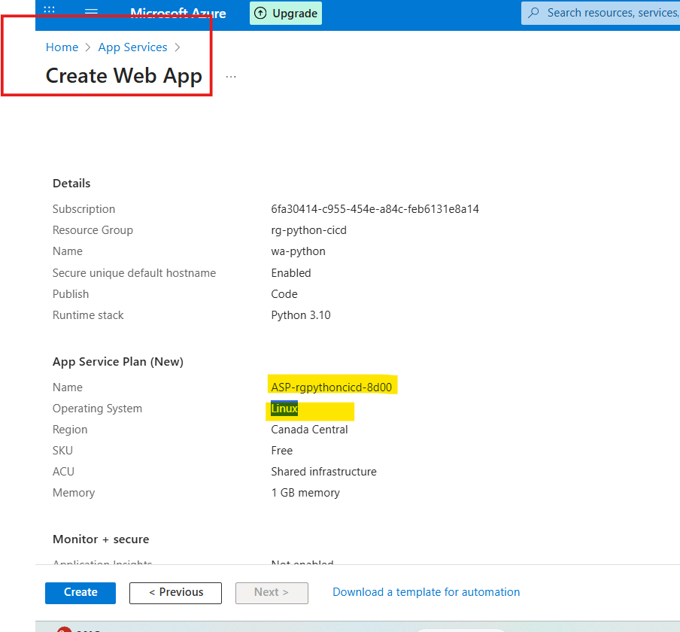

To get details of the app service

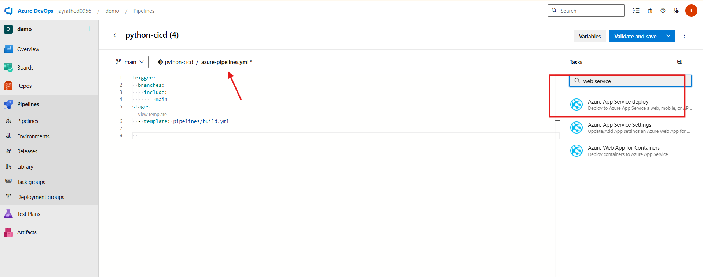

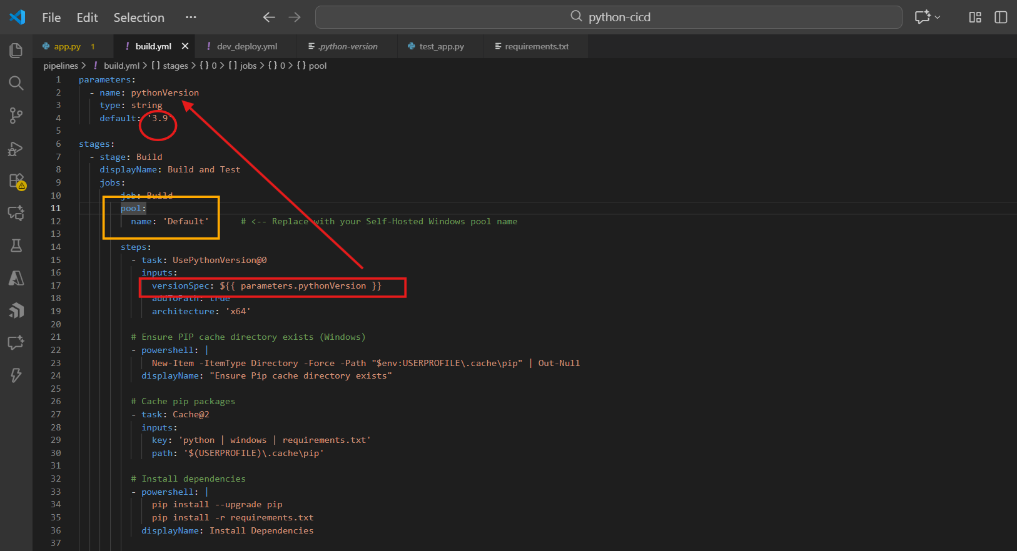
Pool : default when running self-hosted agent.
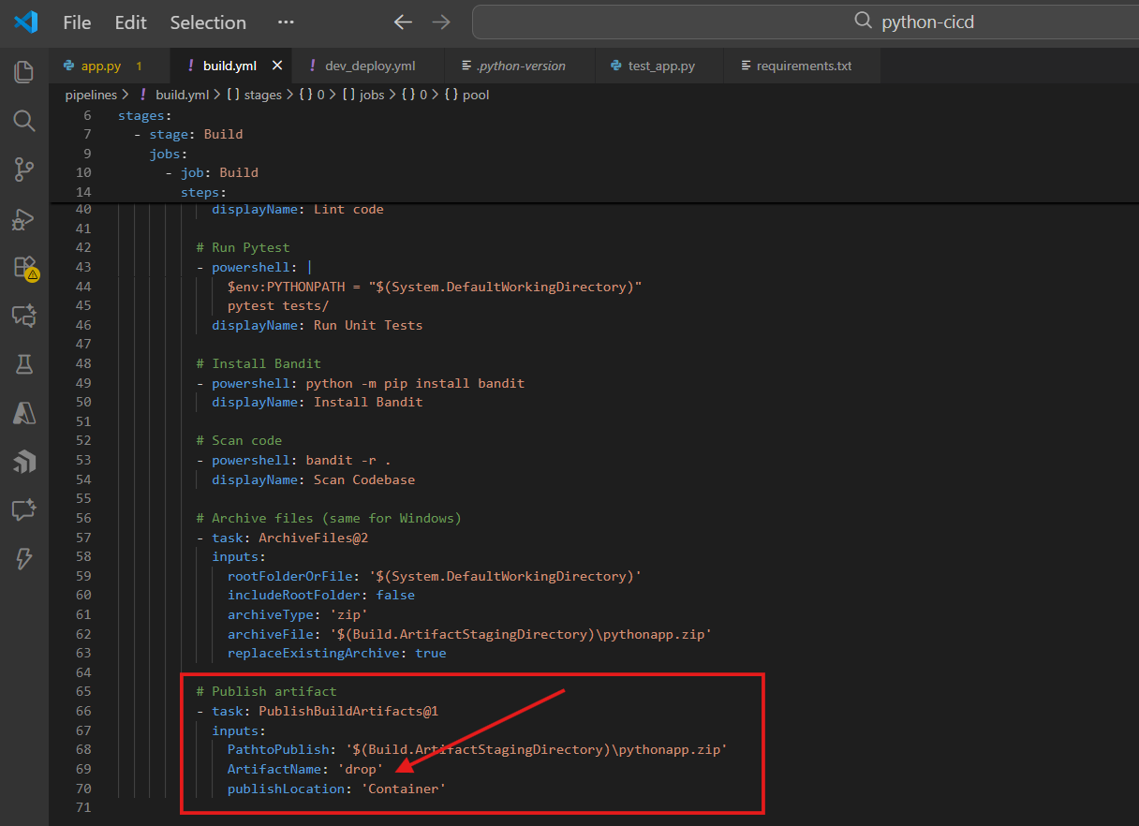
Download inside the drop folder
To get the details of app service:
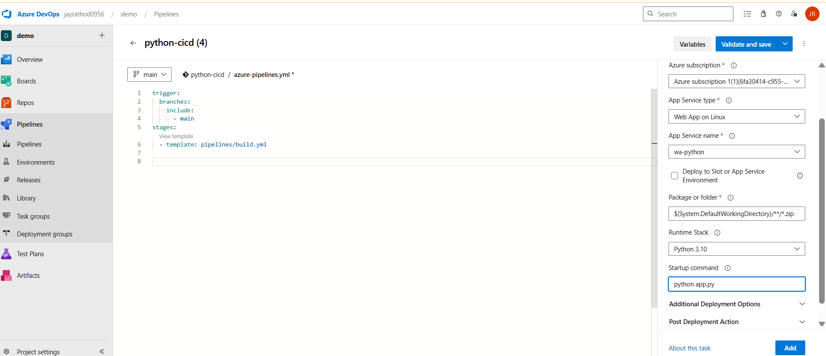
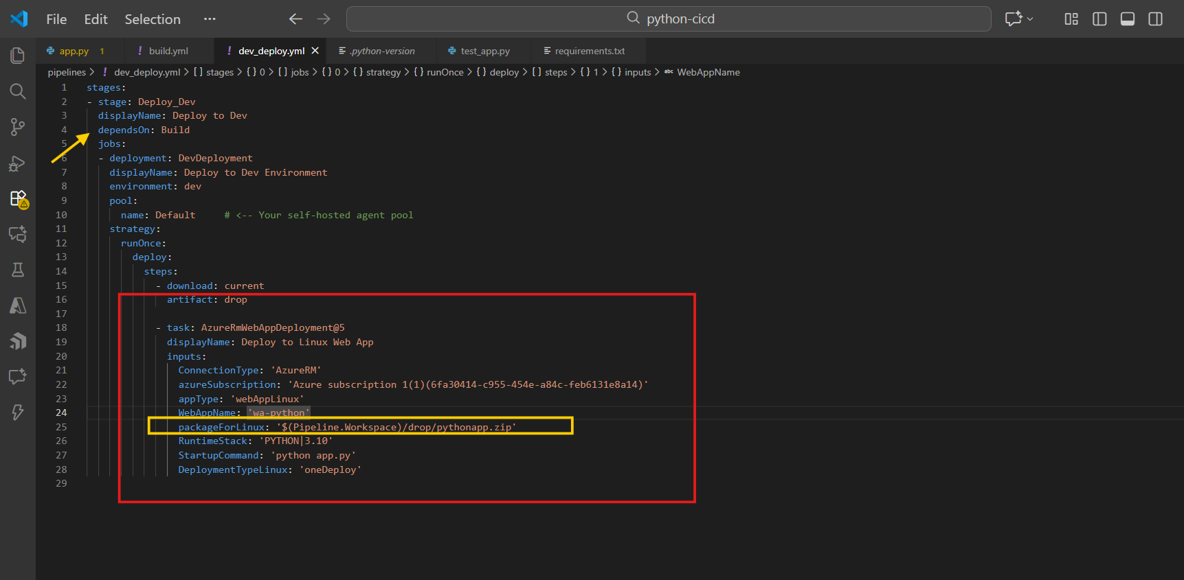

See the path
packageForLinux: '$(Pipeline.Workspace)/drop/pythonapp.zip'

Edit pipeline and add the newly added yml file
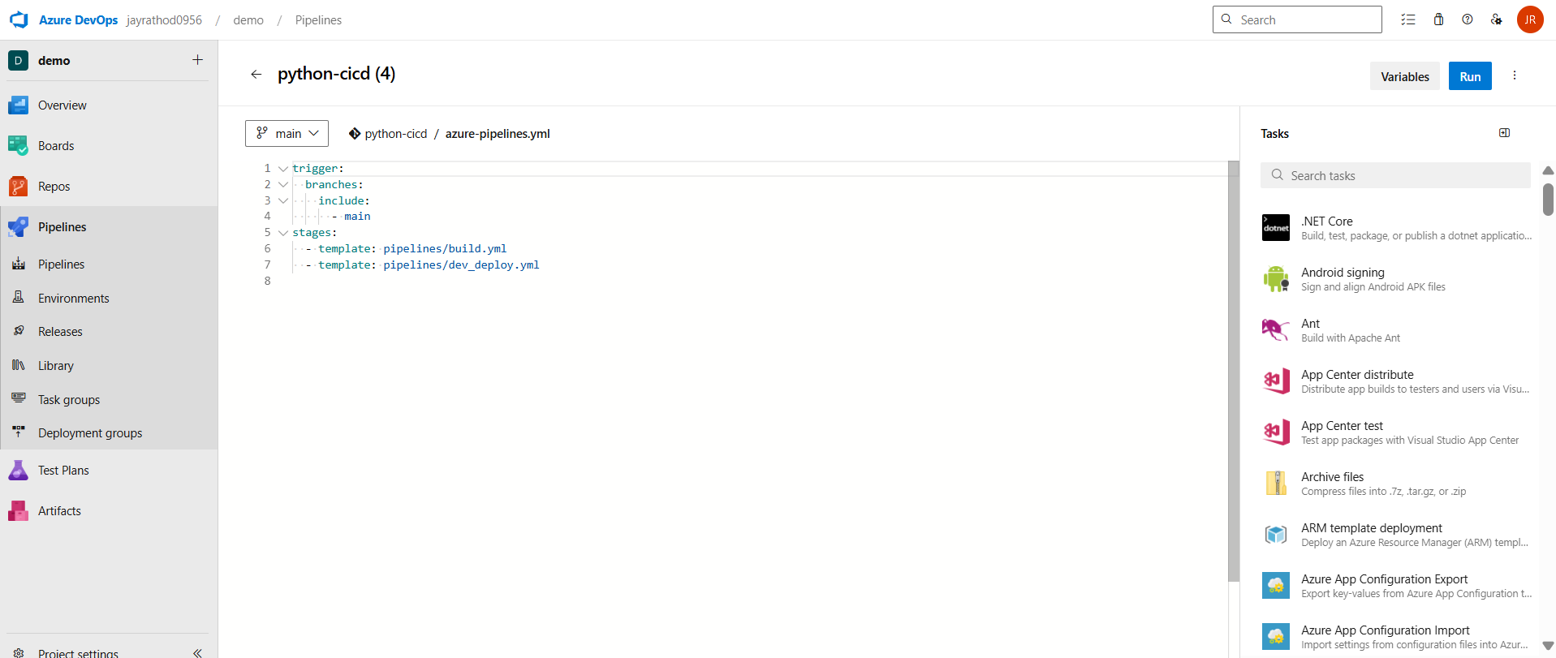

Regression project
git branch -M main
if python is not allow to install
Set-ExecutionPolicy RemoteSigned -Scope LocalMachine
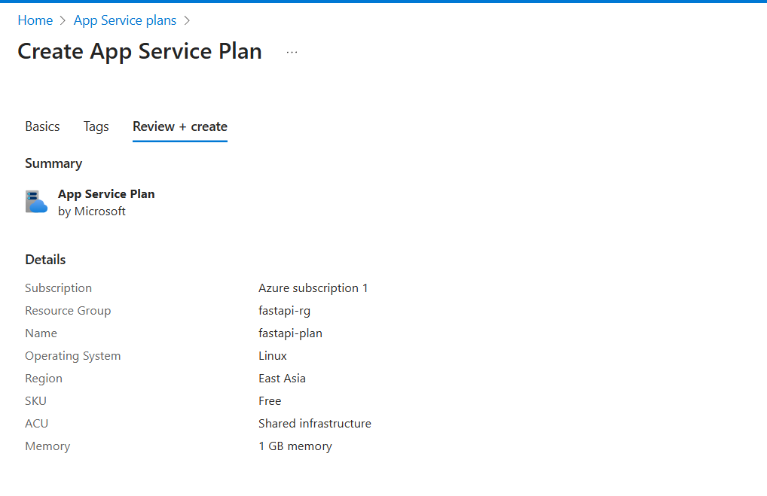
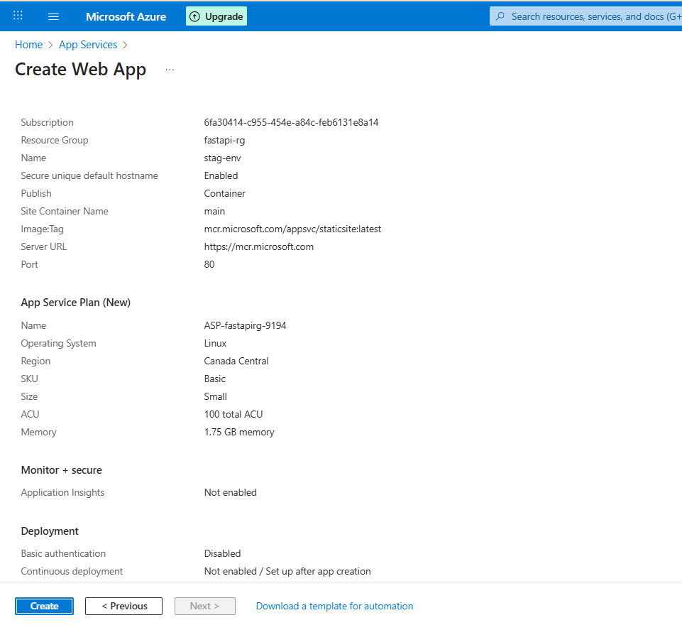
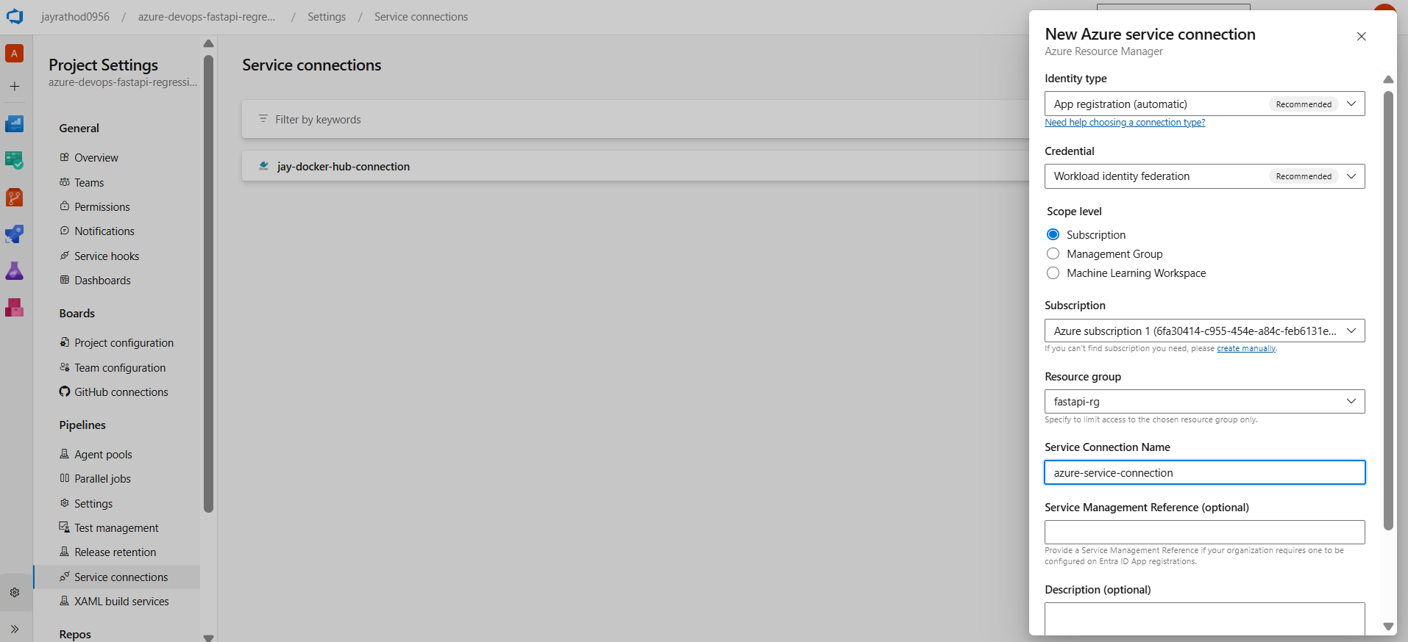
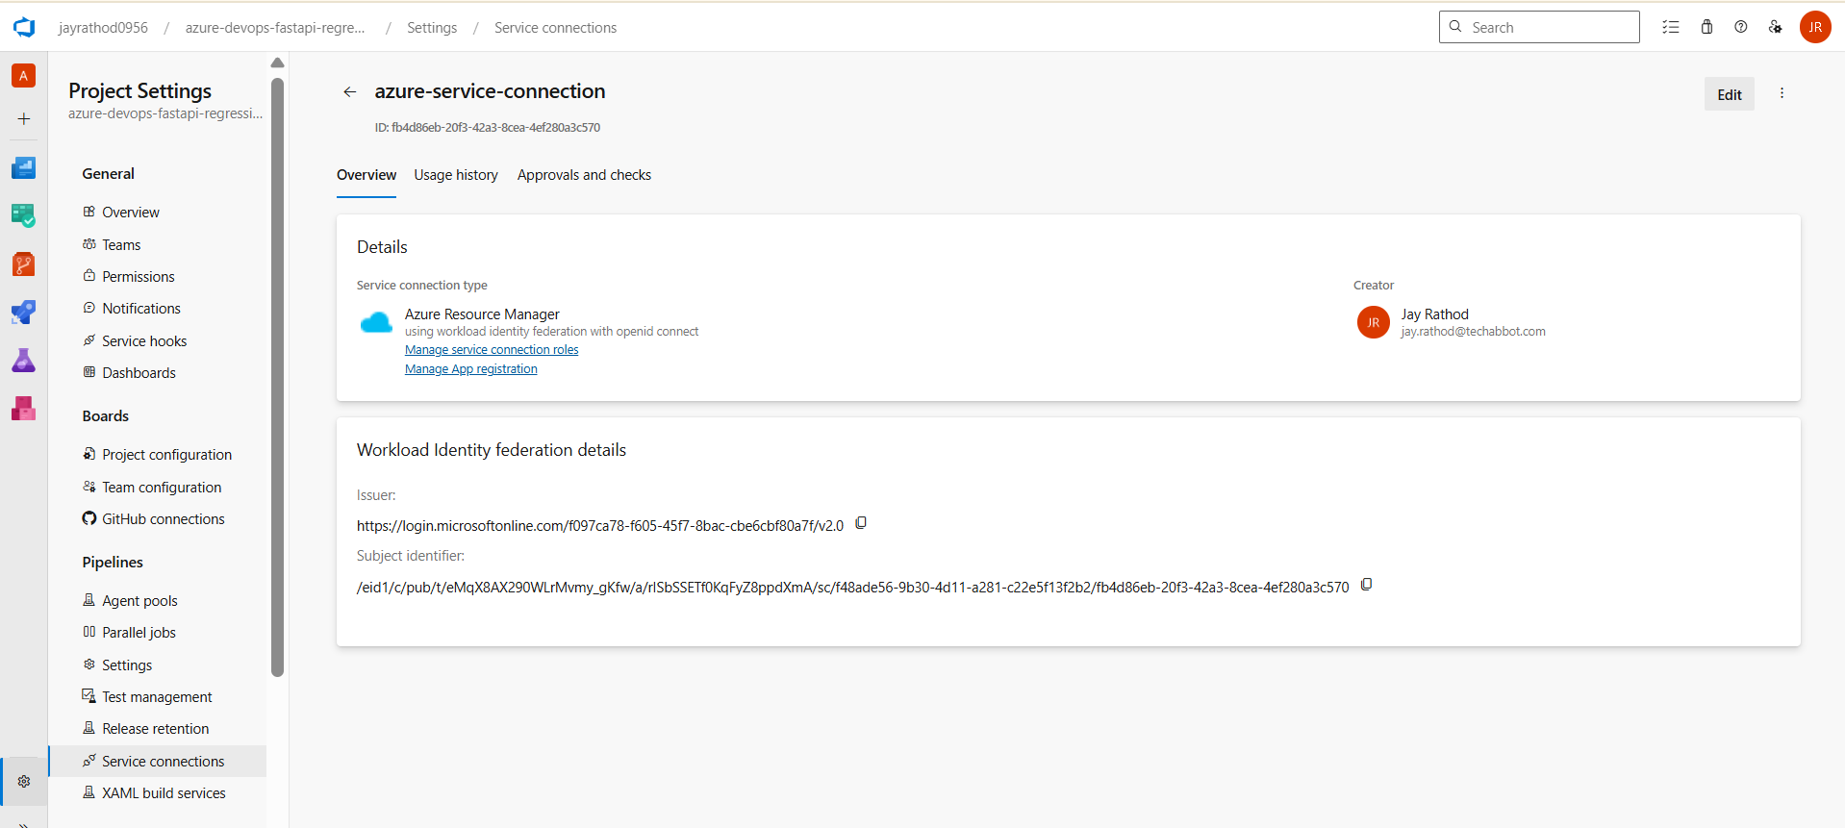
Create container registry
dockerfastapicontainerV1
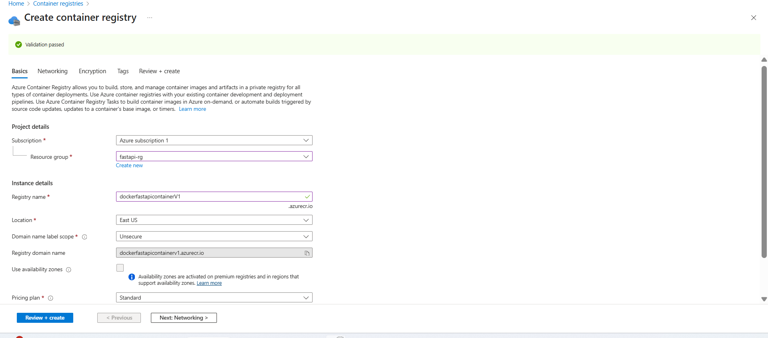
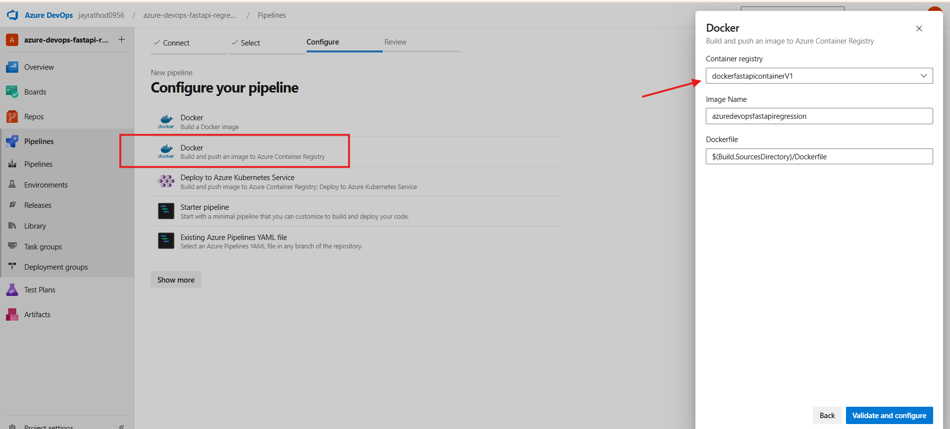

In the pipeline add CLI using assistant
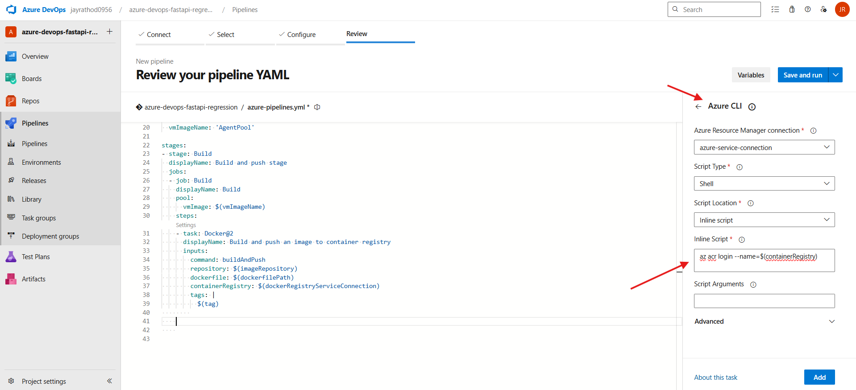
For getting username password from registry
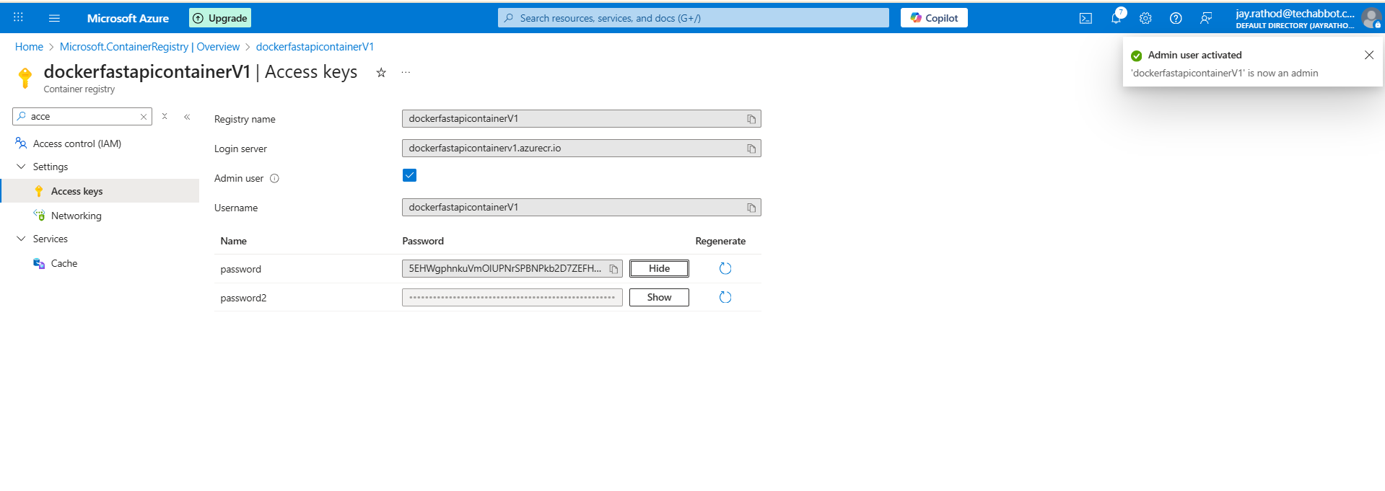
stages:
- stage: Build
displayName: Build and push stage
jobs:
- job: Build
displayName: Build
pool:
name: Default
steps:
- task: Docker@2
displayName: Build and push an image to container registry
inputs:
command: buildAndPush
repository: $(imageRepository)
dockerfile: $(dockerfilePath)
containerRegistry: $(dockerRegistryServiceConnection)
tags: |
$(tag)
The above pipeline push the image that can be verify below

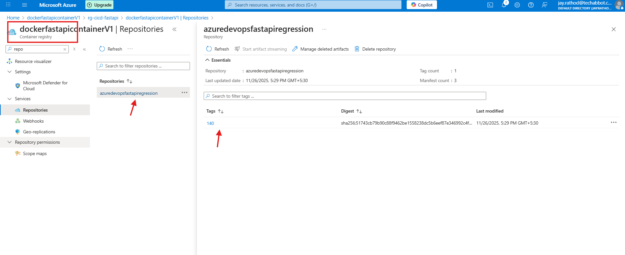
For verifying the deployment
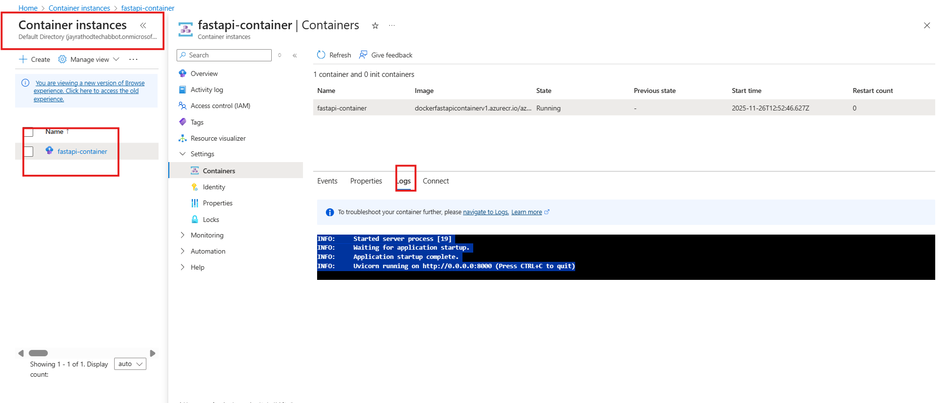

az acr login --name dockerfastapicontainerV1 --resource-group fastapi-rg
